**LPG leakage detection and monitoring using IOT**

**Abstract:**

LP gas leakage and causing fire related accidents are very common in these days. In most of the cases, there is no monitoring system to observe that LP gas is leaking so we can’t take any initiative to control the situation. I’ve modified a low-cost and efficient system of monitoring the leakage using IOT. As IOT is now making everything easily controllable using internet, I’ve selected IOT to complete the operation. You’ll be able the monitor the live data using your android application and also get notification when the value reaches a dangerous level. So, you’ll be notified of the problem when you’re out of your house.

**Hardware part:**

I’ve used a Nodemcu Esp32E module , a LPG leakage detection sensor ( MQ-6) , Buzzer , LED , IC 7805 ( 12v to 5v converter ) , capacitors , resistors, 12v input socket, a PCB board.

I’ve used an adapter that converts 220v ac to 12v dc. Then Ic 7805 converts the 12v dc to 5v dc and fed to the Nodemcu. The sensor also gets input from the 5v source. Nodemcu has an analog pin which is connected to the sensor analog pin.

**Circuit diagram:**

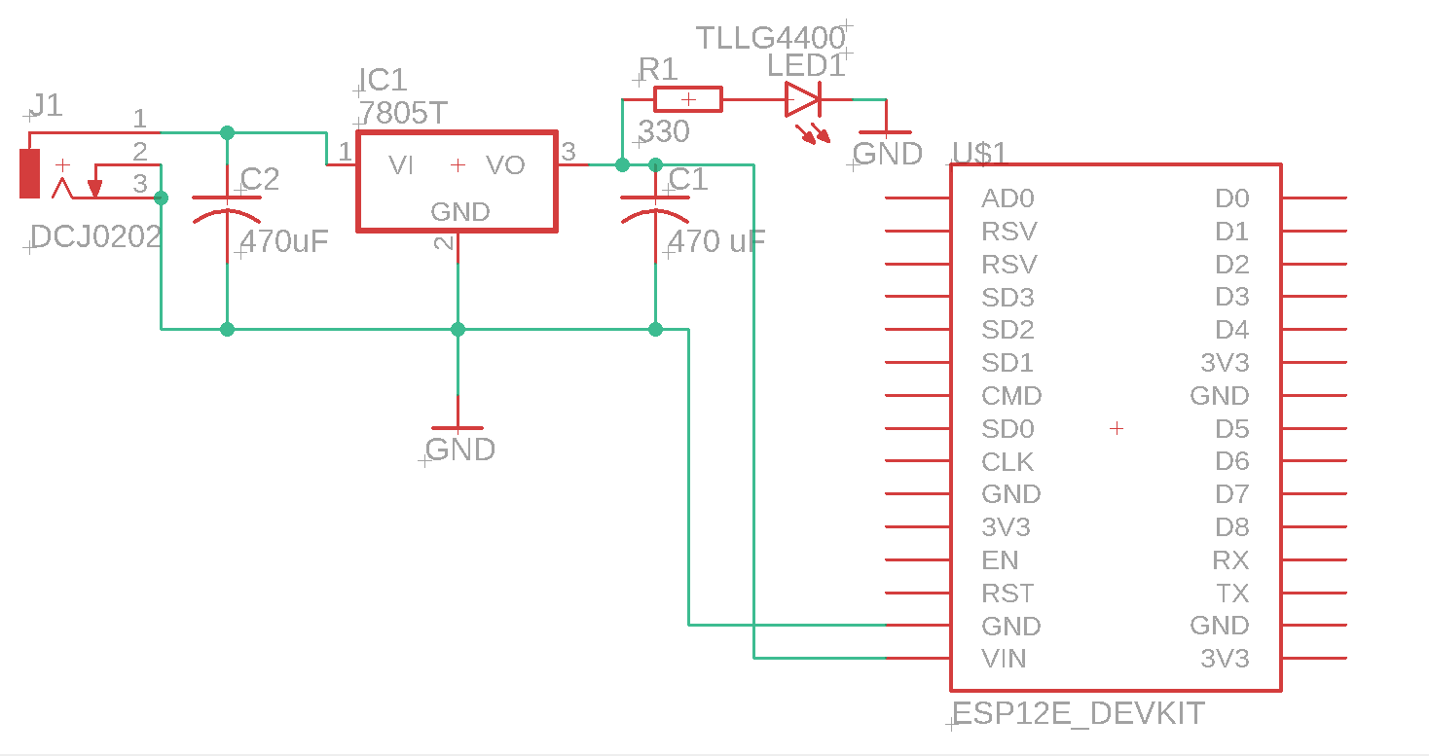

MQ-6 Sensor

**Circuits and PCB files:** [**PCB and Circuit files**](https://drive.google.com/open?id=1pJsy_-e3J4pZu_1YIUGfaWGcu822nyxE)

**Software part:**

I’ve used ‘Blynk’ library to connect it to the internet server. The android application is also based on the ‘Blynk’ MQTT protocol. For this prototype purpose, I’ve used this. For scaling it to a large level, I’ll use a more sophisticated application built on JAVA.

The codes are compiled on Arduino IDE. Codes are given below –

#include <ESP8266WiFi.h>

#include <BlynkSimpleEsp8266.h>

#include <SimpleTimer.h>

#define BLYNK_PRINT Serial // Comment this out to disable prints and save space

char auth[] = "cwCqd9j89iIJi6QNZsvF7Zdb14cBLy9V";

char ssid[] = "Saad";

char pass[] = "12345678";

SimpleTimer timer;

int mq6 = A0; // LPG sensor is connected with the analog pin A0

int data = 0;

void setup()

{

Serial.begin(115200);

Blynk.begin(auth, ssid, pass);

timer.setInterval(1000L, getSendData);

}

void loop()

{

timer.run(); // Initiates SimpleTimer

Blynk.run();

Serial.println(mq6);

}

/***************************************************

* Send Sensor data to Blynk

**************************************************/

void getSendData()

{

data = analogRead(mq6);

Blynk.virtualWrite(V2, data); //virtual pin V3

if (data > 800 )

{

Blynk.notify("LPG leakaging is HIGH!!!");

}

}

**Codes uploaded:** [**Codes are here**](https://drive.google.com/open?id=14WKQkQOxc4UBlyUT1KeKhL3ysNYu7-j4)

**Monitoring Unit:**

Monitoring application looks like this:

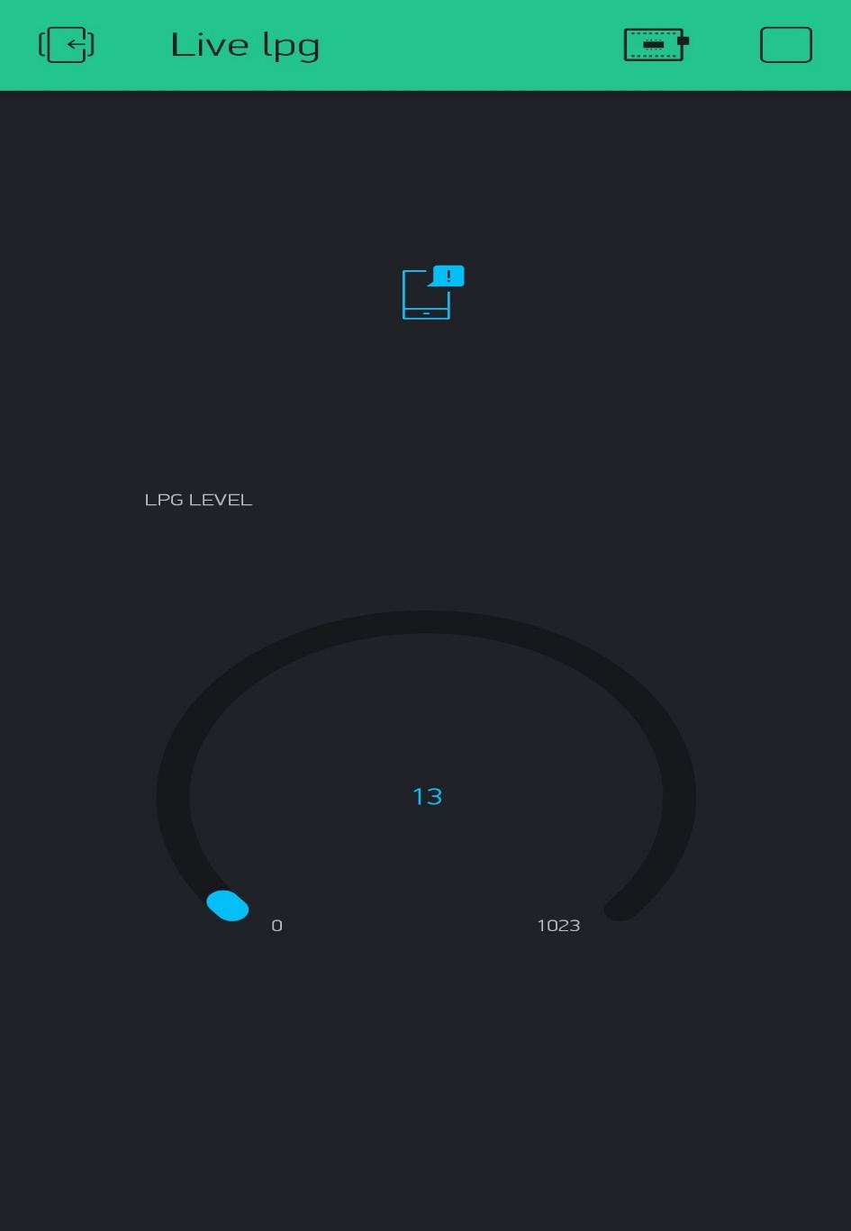

When you apply LPG to the sensor this gauge value increases accurately and show a value. This monitoring system is fully efficient and working very good.

**Live demonstration video:** [**Click here to watch the video**](https://drive.google.com/open?id=1OFU3MX27W-0BEWQQl5ey_bj2xWKnrf7-)